uname
uptime
hostname
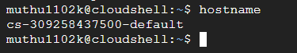
dmesg
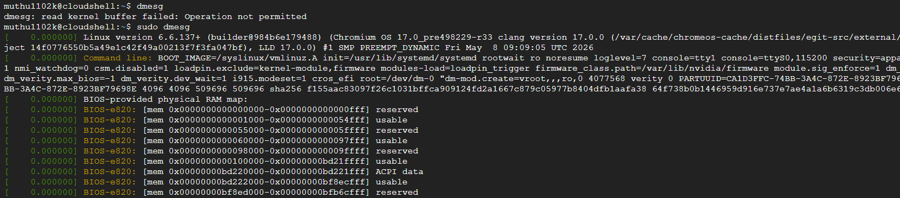
free
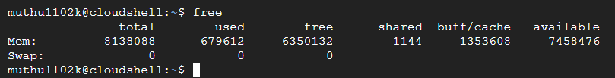
top
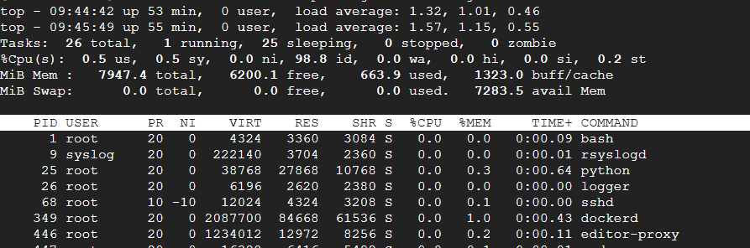
htop
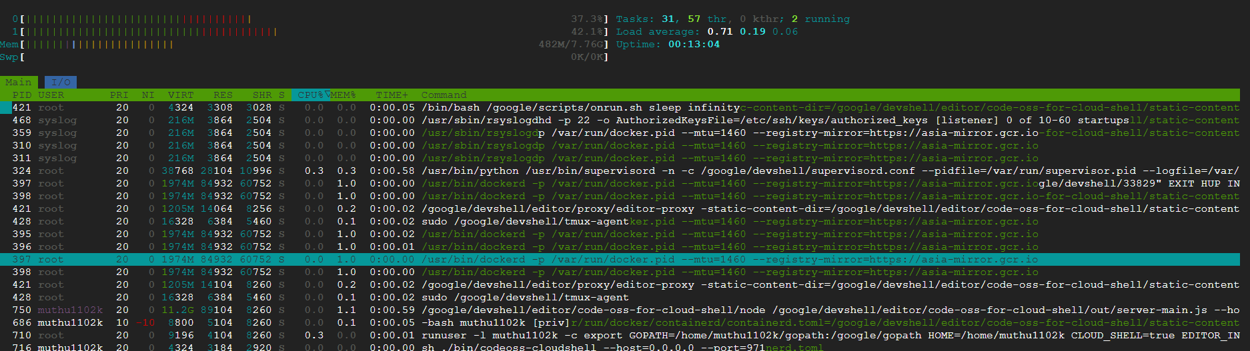
arch
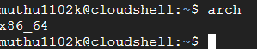
ls
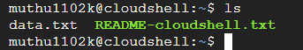
cd
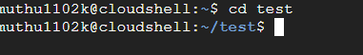
pwd
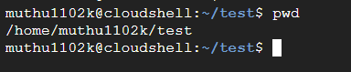
mkdir
rmdir
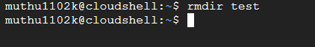

touch
rm
cp
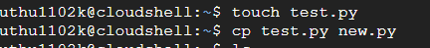
mv
ln
cat
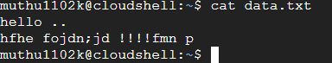
more
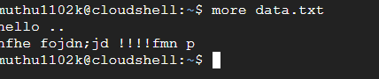
less
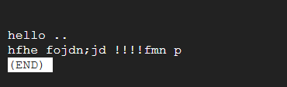
tail
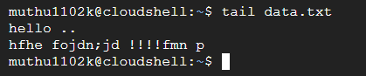
head
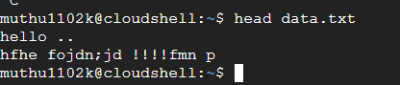
nano
vi/vim
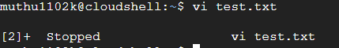
gedit
awk
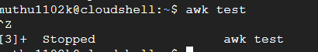
sed
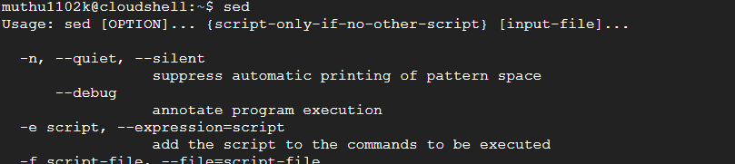
stat
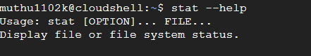
chattr

usermod
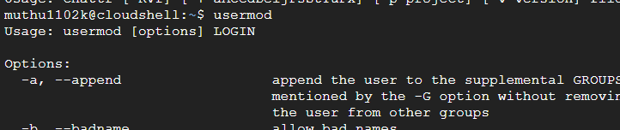
ifconfig
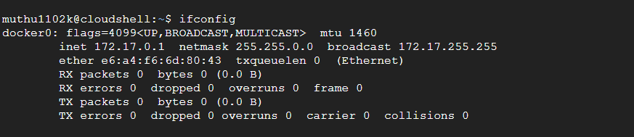
ip
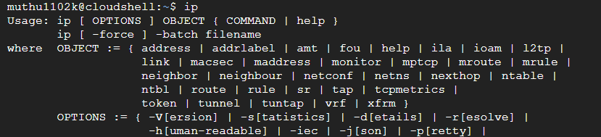
netstat
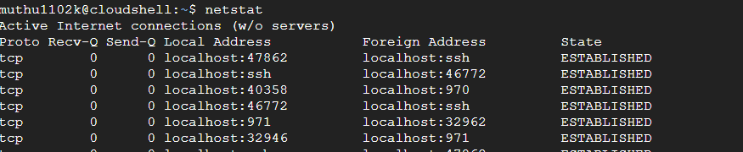
ss
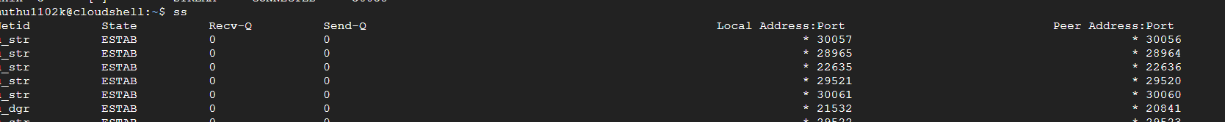

dig
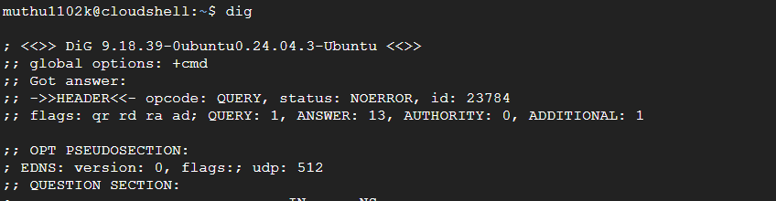
nslookup
ps
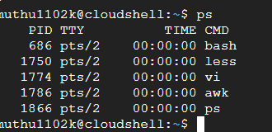
pgrep
pkill
kill
killall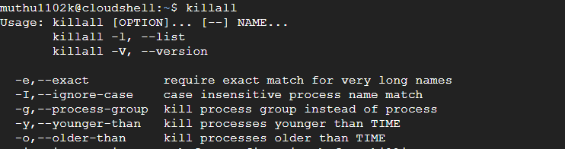
bg
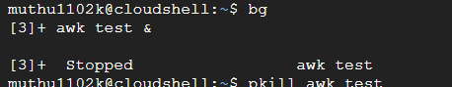
fg
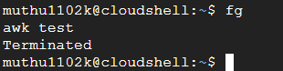
jobs
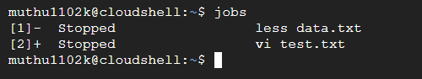
nice
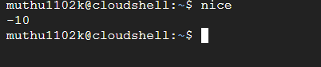
renice
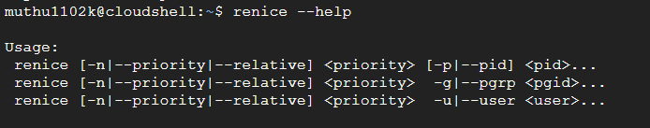
df
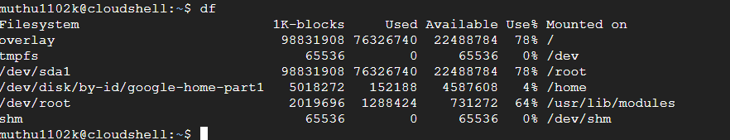

du
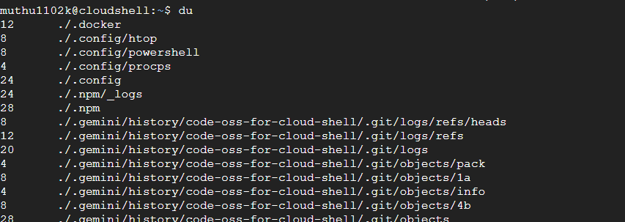
fdisk
mkfs
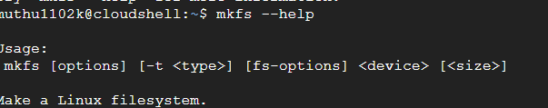
mount
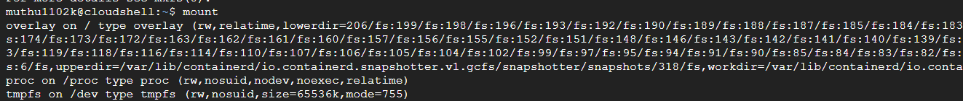
umount
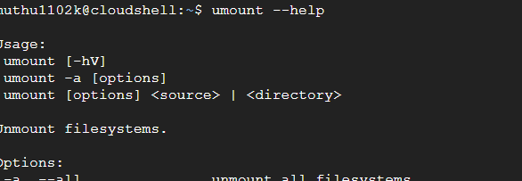

blkid
lablk
parted
tune2fs
top
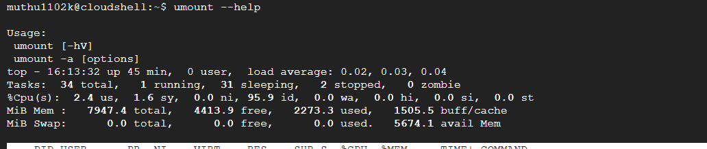
htop
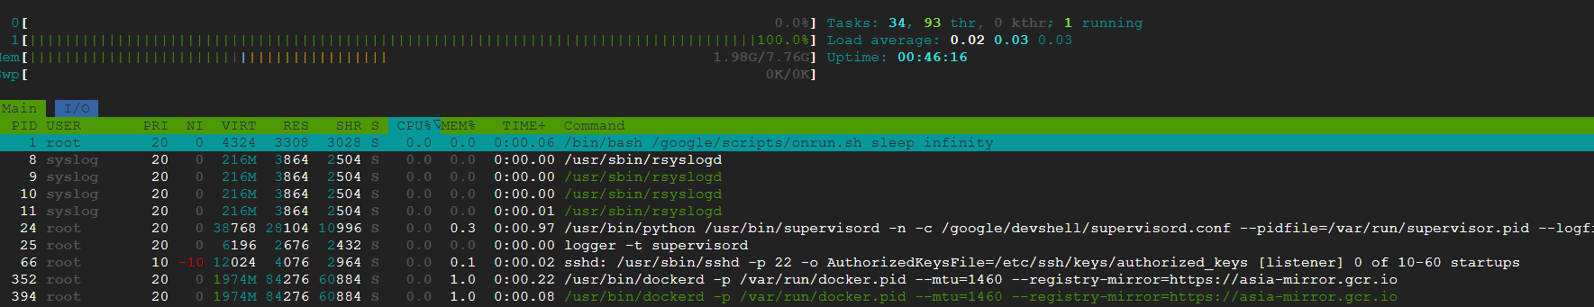
free
